# Testing – Pre-Testing

|  |  |  |  |  |
| --- | --- | --- | --- | --- |
| Test No. | What is being tested? | Test Data | Testing Strategy (Good, Bad, Boundary) | Expected result |
| 1 | Validation on Title | Blank Title Field | Bad | I should not be allowed to proceed, and an exclamation should appear to direct me to the field, so I add data to it. |
| 2 | Validation on ingredient name | Blank ingredient name. Quantity present. | Bad | I should not be allowed to add the ingredient without a name. I should receive an error marker. |
| 3 | Validation on Ingredient Quantity | Blank quantity field. Ingredient Name Present | Bad | I should not be allowed to add the ingredient and be directed to enter a quantity. |
| 4 | Validation on ingredients | Blank Ingredients Box. Title Present. | Bad | I should not be allowed to press next when there are no ingredients in the box, as you cannot have a recipe with no ingredients. |
| 5 | Proceeding to method page | Recipe for beef wellington with correct title and ingredients | Good | As all the data is correct, I should be proceeded onto the add method page. |
| 6 | Method Validation | No Data in method field. | Bad | As no data is present in should receive an error. |
| 7 | Submitting recipe | Correct recipe and method. | Good | I should be able to submit the recipe and then view it. |

# Test Results

# Test Number 1

Here you can see I have pressed the next button with ingredients added but with no title.

As expected, a small exclamation mark has appeared in the Title field directing the user to enter a title before they can proceed.

# 

# Test Number 2

Here you can see I have pressed add ingredient with no ingredient name entered and have received an error directing me to fill in the field.

# 

# Test Number 3

Here you can see I have pressed add ingredient with no quantity entered. You can see that the exclamation highlights the field and directs the user to enter a quantity.

# Test Number 4

Here you can see I have pressed the next button with no ingredients entered but with a title.

As you can see a toast appears telling you that you must enter some ingredients.

# 

# Test Number 5

Here you can see I have pressed the next button with correct information and been direct onto the add method page.

# 

# Test Number 6

Here you can see I have pressed the submit button with no method entered and have received a prompt to enter a method.

# Test Number 6

Here you can see I have pressed the submit button with a correct method entered. When submit is pressed it takes me back to a home page where I can press on it and view it again.

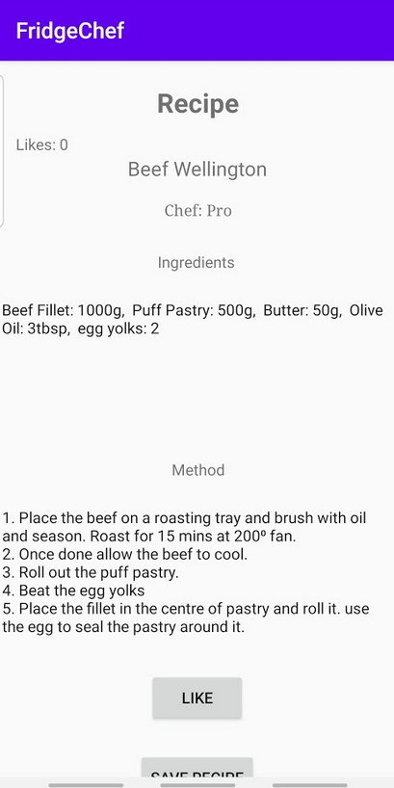

Here you can see I have selected the recipe and can view it. You can that the recipe has all been added and we can see who it’s been added by and how many likes it has.

However, you can see that the method box is not big enough so I can’t see the entire method.

This could quickly be fixed by making the method list box a scrollable box.

# Testing – Post-Testing

|  |  |  |  |  |  |  |
| --- | --- | --- | --- | --- | --- | --- |
| Test No. | What is being tested? | Test Data | Testing Strategy (Good, Bad, Boundary) | Expected result | Actual result | Actions needed |
| 1 | Validation on Title | Blank Title Field | Bad | I should not be allowed to proceed, and an exclamation should appear to direct me to the field, so I add data to it. | As expected. | N/A |
| 2 | Validation on ingredient name | Blank ingredient name. Quantity Present. | Bad | I should not be allowed to add the ingredient without a name. I should receive an error marker. | As expected. | N/A |
| 3 | Validation on Ingredient Quantity | Blank quantity field. Ingredient Name Present | Bad | I should not be allowed to add the ingredient and be directed to enter a quantity. | As expected. | N/A |
| 4 | Validation on ingredients | Blank Ingredients Box. Title Present. | Bad | I should not be allowed to press next when there are no ingredients in the box, as you cannot have a recipe with no ingredients. | As expected. | N/A |
| 5 | Proceeding to method page | Recipe for beef wellington with correct title and ingredients | Good | As all the data is correct, I should be proceeded onto the add method page. | As Expected. | N/A |
| 6 | Method Validation | No Data in method field. | Bad | As no data is present in should receive an error. | As Expected | N/A |
| 7 | Submitting recipe | Correct recipe and method. | Good | I should be able to submit the recipe and then view it. | Works correctly but cannot view the recipe properly | The method box needs to be made a scrollable item. |